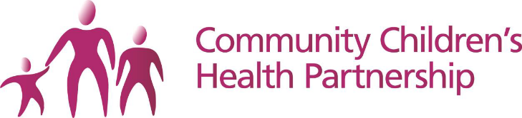 | 
School Immunisation Team
3 Station Road
Pill
Bristol
BS20 0AB
17th September 2021
Dear Parent/ Carer

Nasal Flu Vaccination Programme

The School’s Nasal Flu vaccination programme has now been extended to include all young people from Reception – Year 11 (up to age 18 in Special schools).

The link to the consent form is: https://imms.sirona-cic.org.uk/flu/2021/consent

If you wish for your child to be vaccinated

Please fill in the form (link above) and say ‘Yes’ to the consent option.

If you do not wish for your child to be vaccinated

Please fill in the form (link above) and say ‘No’ to the consent option.

If your child has already received their Flu vaccination this Autumn

Please fill in the form (link above) and say ‘No’ to the consent option, choosing Already Immunised as the Reason

If we do not receive a form from you we may need to contact you on the day in order to discuss your wishes. Therefore, it is very important that you return the form to us in advance in order to make your wishes known.

Please note that all forms must be completed by 5pm on the day prior to the first session at your child’s school in order to be entered on the system.

If your child is not in school on the schools session dates we will be running catch-up clinics across the Bristol, North Somerset and South Gloucestershire region, you will receive information about these after the school sessions.

In the meantime, if you have any questions please contact the School Immunisation Team on 01275 373104 or email sirona.sch-imms@nhs.net

Yours faithfully,

Karen Evans
Head of Specialist Services for Children

