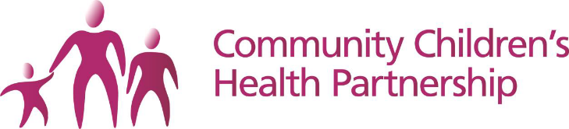 | 
School Immunisation Team
3 Station Road
Pill
Bristol
BS20 0AB
17th September 2021

Dear Parent/ Carer

Covid-19 Vaccination Programme

As announced on Tuesday 14th September 2021 the COVID-19 programme has now been expanded to include vaccinating healthy 12-15 year olds. This vaccination will be free of charge and our highest priority is making it easy for children to access one dose of the vaccine before the winter.

The main purpose of the COVID-19 school age vaccination programme is to provide protection to the children who receive the vaccine and may help to reduce transmission of COVID-19 in the wider population

The link to the consent form is: https://imms.sirona-cic.org.uk/covid19/2021/consent

If you wish for your child to be vaccinated

Please fill in the form (link above) and say ‘Yes’ to the consent option.

If you do not wish for your child to be vaccinated

Please fill in the form (link above) and say ‘No’ to the consent option.

If your child has already received the COVID-19 vaccine

Please fill in the form (link above) and say ‘No’ to the consent option choosing ‘Already Immunised’ as the reason.

If we do not receive a form from you we may need to contact you on the day in order to discuss your wishes. Therefore, it is very important that you return the form to us in advance in order to make your wishes known.

Please note that all forms must be completed by 5pm on the day prior to the first session at your child’s school in order to be entered on the system.

For more information about the COVID-19 vaccination programme for this age group please see https://www.gov.uk/government/publications/covid-19-vaccination-resources-for-children-and-young-people/covid-19-vaccination-a-guide-for-eligible-children-and-young-people-aged-12-to-17

If your child is not in school on the schools session dates we will be running catch-up clinics across the Bristol, North Somerset and South Gloucestershire region, you will receive information about these after the school sessions.

Nasal Flu
We will be offering the Nasal Flu vaccinations alongside the COVID-19 vaccinations; this is in line with Public Health guidelines and will mean less disruption for schools and young people.

Consent
You will be receiving a consent form for the Nasal Flu vaccine separately and will be able to indicate your wishes to each of the vaccines separately.

Administration
The current evidence has shown it is safe to give both vaccines at the same time and will not increase any risk of adverse effects.

In the meantime, if you have any questions please contact the School Immunisation Team on 01275 373104 or email sirona.sch-imms@nhs.net

Yours faithfully,

Karen Evans
Head of Specialist Services for Children

